Overall Testing Report

This document mainly records the testing results of different types of testing. And it contains some details in the testing which STD not covered. And all the test cases are in the test case excel document [here](https://docs.google.com/spreadsheets/d/1CGYv17k1YQjrvvOj_J151QLHhNvMrDJkOoC_8Az-tYg/edit#gid=0).

1. **Unit testing**

We mainly use codeception by PHPunit framework for unit testing, and the test code is in Github. And for javascript, we use Jasmine.

Result:

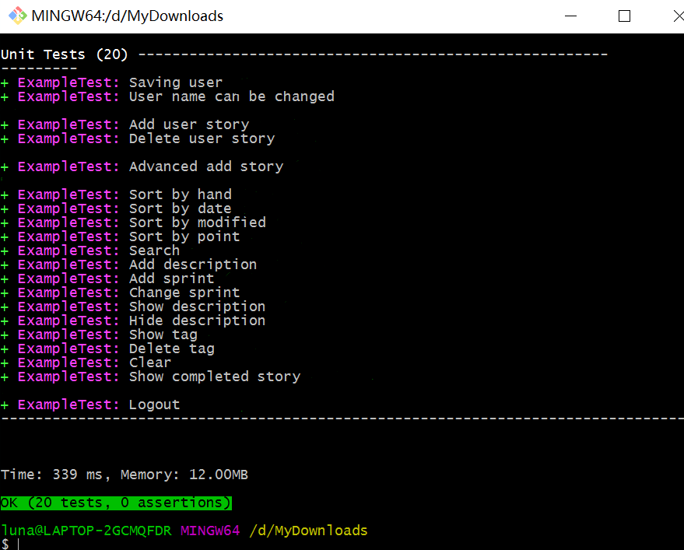

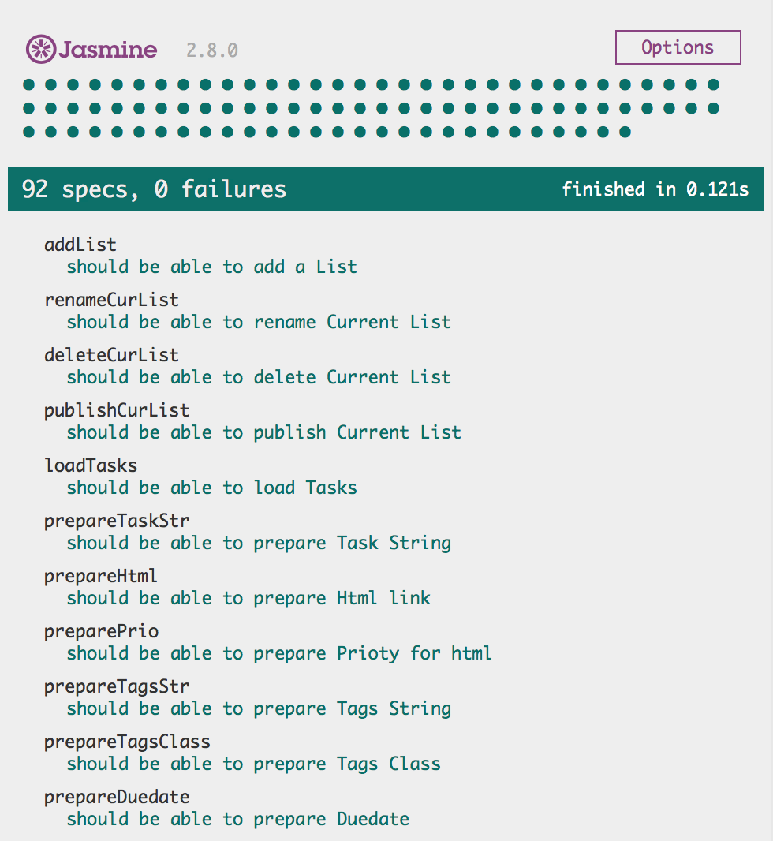

1. **Integration testing**

Weleverage Selenium and Eclipse to perform the integration test.

Test code has been uploaded to Github.

Test metrics are described in STD.

Screenshot:

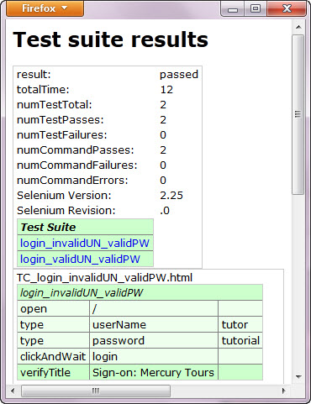

1. **Functional testing**

*Considering to not do functional testing, because according to the basic steps of web application testing. And also acceptance testing contains functional testing.*

1. **Compatibility testing**

Browser compatibility:  
Test Web application for correct function on several browsers, including Firefox, IE and Chrome. Ideally our Web application handles browser differences elegantly.  
Check application function with a variety of browser security profile settings  
Verify application function with browser features turned-off

Check browser rendering of your application's user interface  
Check the browser's security settings for cross domain access and hacks  
Verify consistent application function across multiple versions of a browser

Operating Environment Compatibility:  
Check application user interface rendering on OS windowing systems  
Check desktop integration functions, including drag-and-drop and file selection  
Test our web application on different operating systems, including Windows, MAC and Linux.

Our [compatibility testing report](https://docs.google.com/spreadsheets/d/11mzhvmjOF9JqWUiNP1dPKbpI1_EIGMDwtukGDSJHVHg/edit#gid=0) links here! !

*Update during each iteration.* (In our report, in each iteration, we check both the browser compatibility and operating environment compatibility. And we record the last success checking date of each user story in different environment and different browsers.)

1. **Acceptance testing**

For each user story, we need an acceptance test. And we use [codeception](http://codeception.com/quickstart) for our acceptance test. It can deal with all the acceptance at the same time, and it is like an automatic tool by code.

Example acceptance test:

We got the scenario that a user would like to login into our website.

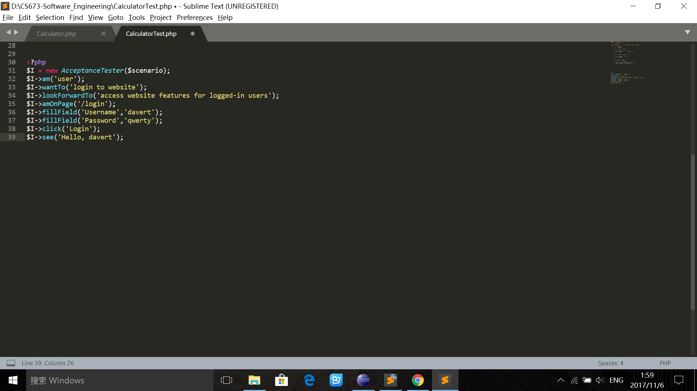

Before we execute this test, we should make sure that the website is running on a local web server.

After configuring the URL we can run this test.

We can see this output:

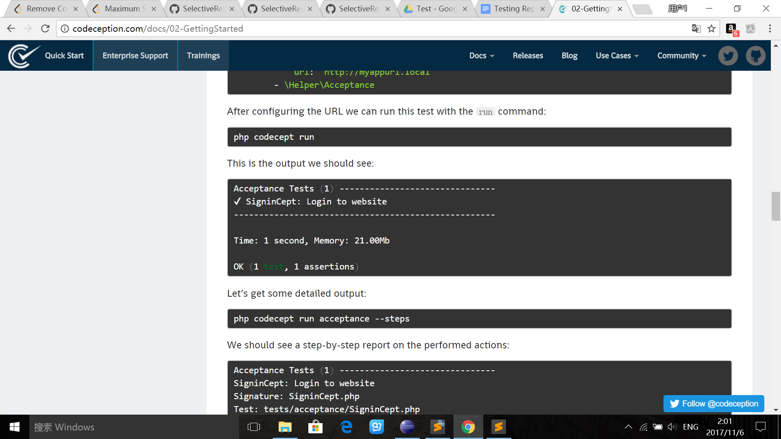

And the test code for acceptance test is in Github.

Results

We total have 17 acceptance tests, and testing results are below:

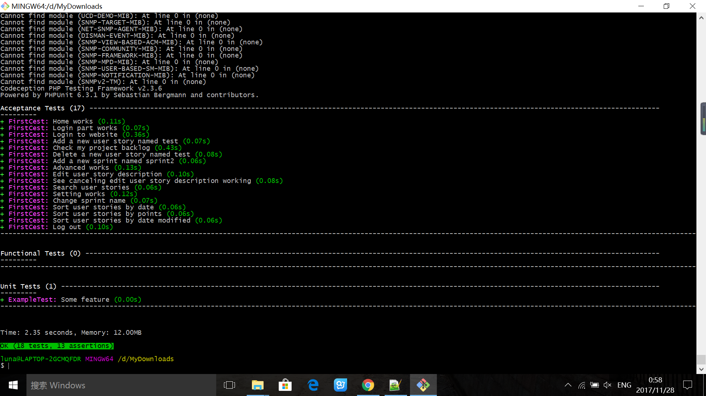

It took 2.35 seconds to pass all the 17 acceptance tests, and we can see different testing user story description in the picture.

The code coverage is also collected by codeception.

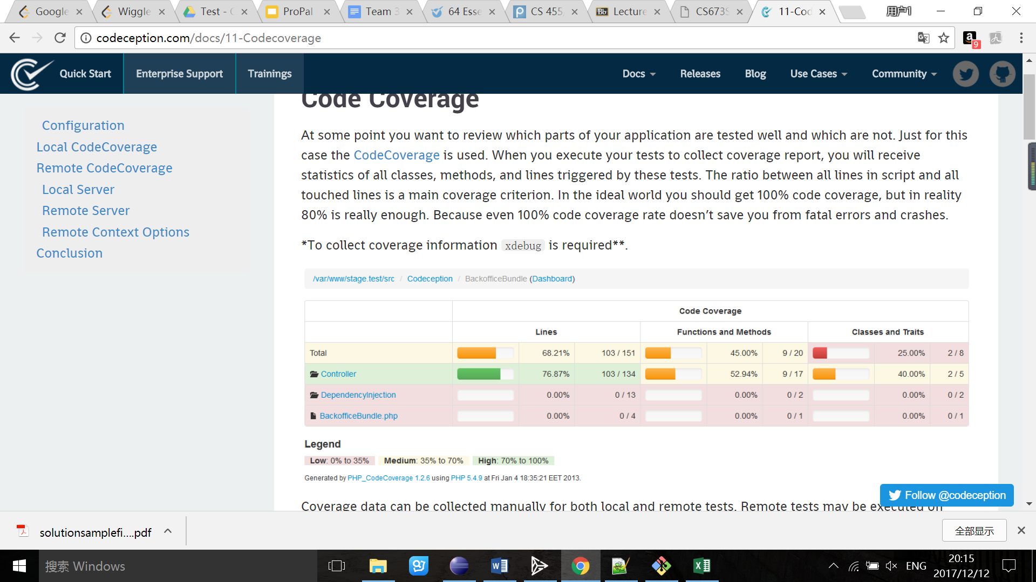

1. **Usability testing**

**Updated [Usability testing report](https://docs.google.com/spreadsheets/d/1XNS0c0pXolfsuLP4npwQBJDy25rP487TCLHwJFnlONQ/edit#gid=0).

Example report image:

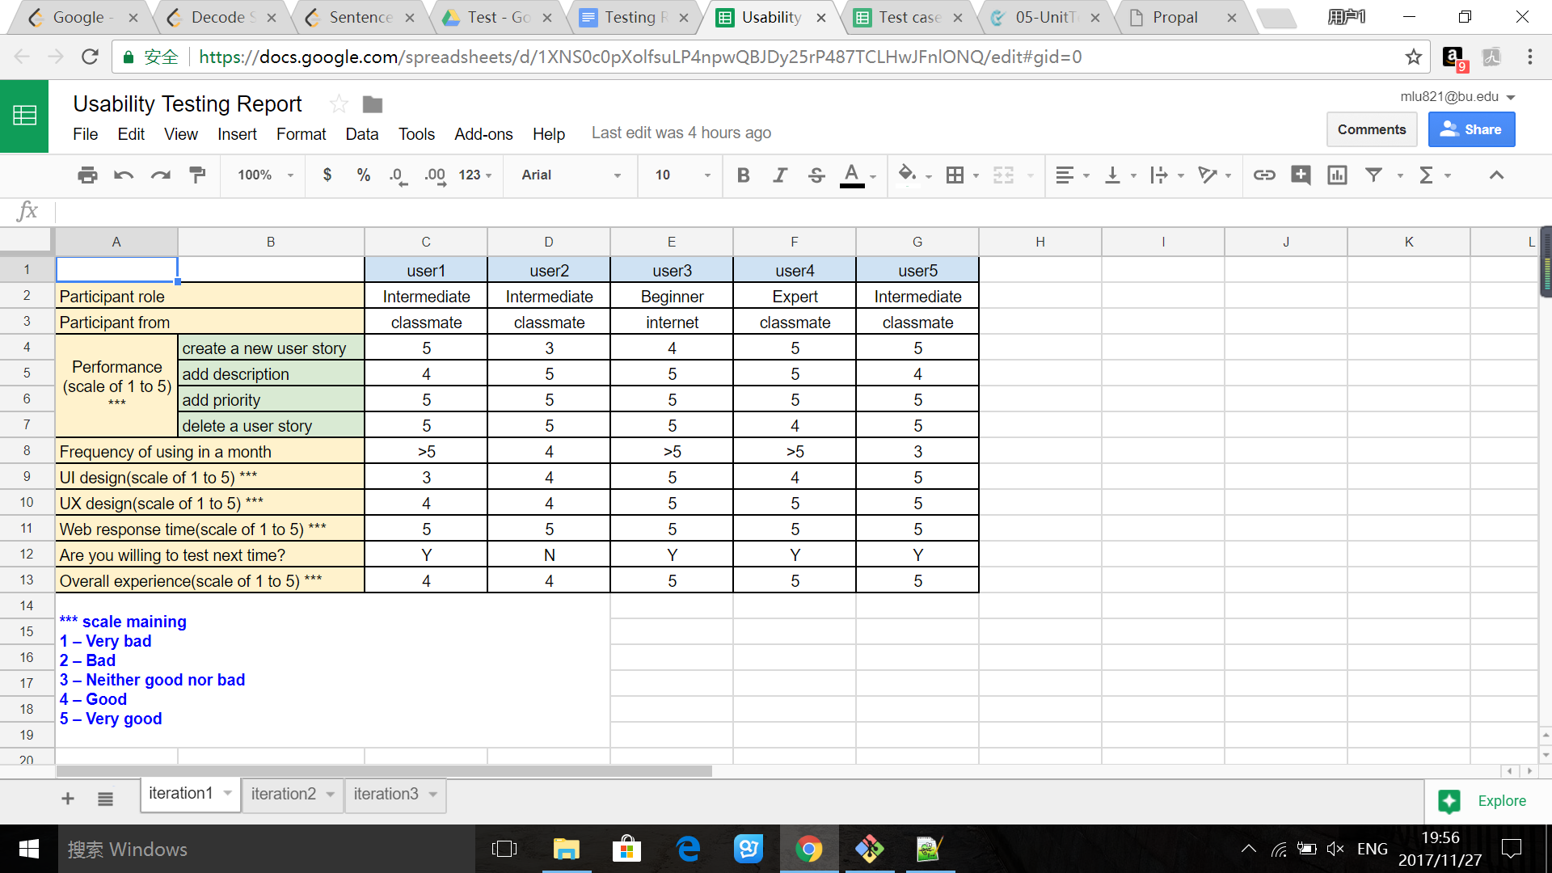

*Iteration 1:*

### Here are the few steps we applied in our usability testing for iteration one, and we will keep these steps for future usability testing in the following iterations.

### **Step 1: Goal**

Our goal is mainly to figure out if our web application is convenient for users, and if the web design is user-friendly.

The current practice is to test 3-5 participants for a study. Research shows that testing 5 participants reveals 80% of the problems whereas 9 participants reveal 95% of the problems. Considering the time limit and complexity of our current product, we decide to test 3 participants for iteration 1.

### **Step 2: Recruiting**

Depending upon the scope and intention of our project, we need to select the right participants based on:

* Drupal experience: Beginner, Intermediate, Expert user
* First time user or Experienced user

Where could we find participants?

* Recruit friends and colleagues if they fit the profile
* Recruit through social networking tools like Twitter, Facebook, LinkedIn, etc.

### **Step 3: Preparing for the study**

*Part One: Pre Session questions*

These are the questions we ask the participants before diving them into the tasks.

* What is the participant's expectation with a feature like adding a new user story?
* How does the participant expect adding description to work?
* What are the most important things that you would like to do with editing user story?

*Part Two: Post Session questions*

This is the time for us to ask participants their overall experience with the feature and how does it do overall. Asking participants to rate their experience is of great value (Some of the rating parameters are: Effectiveness, Efficiency, Satisfaction, Ease of Use, Value, etc.)

* How was your overall experience?
* What are the things that you liked the most and the least?
* If you rate this feature in terms of ease of use on a scale of 1 to 5, where 1 being completely unusable and 5 being completely usable, how would you rate?

### **Step 4: Conducting**

We greet the participants and manage the participants’ expectation from the test. Inform the participants how long is it going to take, think aloud, be candid about their comments.

### **Step 5: Analyzing**

We go through all the participant notes for a particular positive, issue and observation and note how many times the issue was encountered. After the draft priorities, associate every issue to a severity of the problem and the impact/frequency of the problem.

### **Step 6: Reporting**

We collate the results and figure out which part we need to improve.

Because iteration 1 we finished the basic part of our project -- user stories part, and this part doesn’t have many for us to test, the usability testing for each participant is within 4 minutes. Except for feature adding in iteration 2, we need to improve these following part according to analysis report.

* The way to add a new user story
* UI design
* Usability testing questions

*Iteration 2:*

Still follow the six steps in iteration 1.

In iteration 2, we recruit total 5 participants, and four of them are from the last iteration usability testing.

In iteration 2, our web application performs much better than iteration 1. And functions and features in application is more complete. We can easily see from the feedback from the participants.

*Iteration 3:*

Still follow the six steps in iteration 1.

In iteration 3, we also recruit 5 participants, and four of them are from the last iteration usability testing.

In the final iteration, we found that the various requirements are well completed, and participants’ experience is much better than iteration 1. But for future work, we still need to improve our roles of users and assign authority to different role of user.